Goal: Design a phase matched structure, make the group velocity of the SH mode to be in between those of the TE and TM fundamental modes.

The following are different trials.

1. Modal phase matching using higher order mode in the transverse direction:

Simulations: Similar to modal PM using a higher order mode in the vertical direction, ridge waveguides with lower “effective index” in the center of the ridge are simulated.

Results: SH field is mainly confined in the core layer, even if the refractive index difference is extremely small. Higher order SH modes have effective indices close to material indices, much higher than the effective indices of fundamental wavelength modes, with the values around 3.5 and 3.1, respectively. Effective index method is not accurate for these structures.

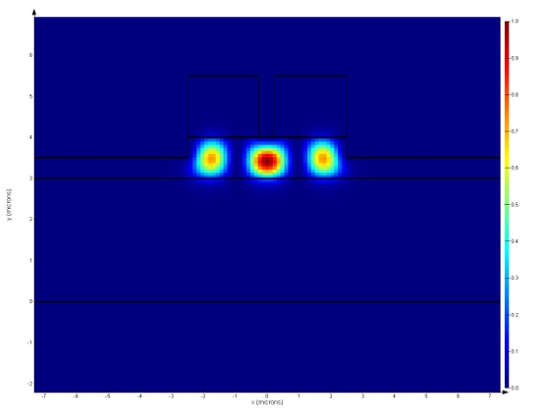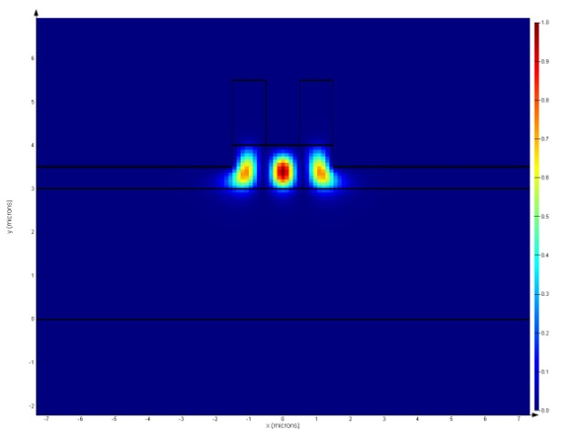

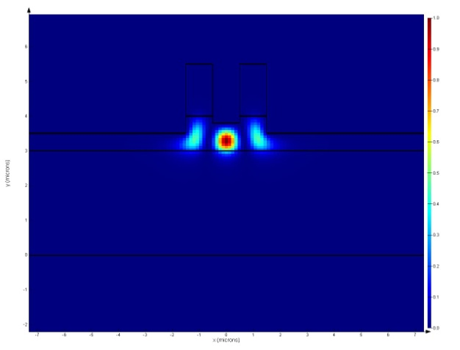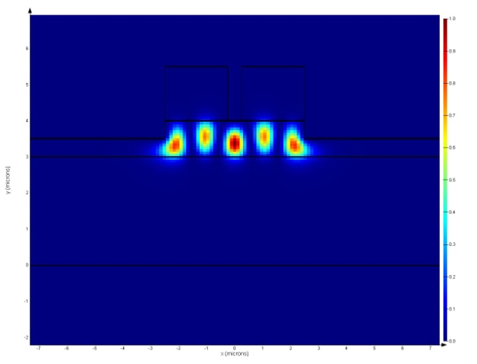

1. Modal phase matching using a higher order mode in the vertical direction, with one of the fundamental modes to be Bragg mode:

Simulations: Both symmetric and asymmetric BRWs are designed for TE fundamental mode. Then TM fundamental mode and higher order SH modes are calculated.

Results: Unable to achieve phase matching, as the Bragg modes have much lower effective indices.

Asymmetric case:

Neff_sweep.eps

SH_mode.eps

Symmetric case:

Neff_QrW_BRW.eps

SH_mode1.eps

With slightly different parameters:

SH_mode2.eps

Thus even if the mode order is 9 or 10, the effective index is still too high. Note that some of the higher order modes are Bragg modes, even if the Bragg stacks are designed for fundamental wavelength.

1. Chirped BRWs

Simulations: The effective index and group velocity of a Bragg mode in linearly chirped BRWs are calculated.

Results: The group velocity can only be slightly increased, still much lower that the group velocities of the fundamental wavelength modes (around ).

neff_chirped_sweep.epsVg_sweep.eps

BRW_mode1.eps

BRW_mode3.eps

BRW_mode2.eps

1. Changing the ridge width

Simulations: Calculating the group velocities of the three modes with different ridge widths.

Results: The group velocities of the TE and TM modes at 1550nm and TE Bragg mode at 775nm decrease to $8.0×{10}^{7},8.7×{10}^{7}$ and $7.2×{10}^{7} m/s$ respectively, when the ridge width decrease to 500 nm. Thus the requirement is not satisfied. The dependence of phase-matching wavelength on ridge width is not considered.