Research Topics for Graduate Students – 2016
Professor Peter R. Herman
University of Toronto, Electrical and Computer Engineering
http://photonics.light.utoronto.ca/laserphotonics/

MASc and PhD Projects: (5 funded MASc or PhD positions available)

Laser Interaction Science:
All projects are grounded on laser technology and high intensity material interactions:

The symphony of colourful flashes emitted during intense laser interaction offer a telling insight into the dramatic undulating physics that evolves rapidly as material is transformed through various states of matter, heated to sun-like temperatures, shocked to explosive pressure, and finally ejected at supersonic velocity. Understanding and gaining control over such complex phenomena is a major challenge in science, and a formidable goal for industry that toils to steer the otherwise wanton laser processes into reliable and reproducible processes demanded in our most advanced manufacturing sectors.
Laser Structured
Lab-in-Fiber

Graduate students in our group seek a fundamental understanding of ultrafast laser interactions to transform transparent materials in new unforeseen ways. 'Intelligent' laser control methods are developed that manage highly nonlinear light interactions and offer a new scope for three-dimensional additive or subtractive internal structuring. Many of the research directions below have generated new Intellectual Property and permitted our group to invent new laser interaction method. This fundamental basis has created the platform for manufacturing novel optical, micro-mechanical, and microfluidic systems that underlie a broad range of applications from optical telecommunication to microsurgery. We are currently applying spatio-temporal beam shaping tools with burst train control to adaptively steer the laser focal volume and induce selective material modification. The transient melt, vaporization and plasma transformations are further followed with "5-D" spectroscopic and time-resolved imaging tools. This approach enables the graduate student to uniquely harvest the rich optical signature of laser interaction physics as cutting, welding, scribing, or refractive index modification take shape in real time. We are aiming to develop self-learning algorithms for spatio-temporal beam shaping that can control the size, symmetry, position, stress profile, and morphology of the material for various application directions.

Collaborative Research:

The fundamental principles of laser interaction physics are applied in several project areas, with highly collaborative linkages to local and international academic groups in multidisciplinary fields of science, engineering and medicine. Several projects also aim to develop new laser manufacturing processes with various industry partners, and to showcase new integrated device concepts in micro-optics, photonics, distributed sensor networks, lab-in-fiber, lab-in-a-film, biomedical probes and smart catheters. These industry partners serve in the Telecom, Photovoltaic, Biomedical, Security, Defense, and Consumer Electronic sectors and include local and well-known international companies. The program encourages entrepreneurship, with active engagement in industry projects and spin-out companies, and training programs varying from protection of intellectual property to technology-based entrepreneurship.

Thesis Topics:
All projects involve hands-on research in multi-million dollar laser and diagnostic facilities. The University of Toronto further provides access to advanced clean room fabrication and characterization facilities (i.e. e-beam lithography, ion-milling/SEM, thin film deposition, Microfluidics/lab-on-chip). A project will also typically require design and modelling (i.e. optical circuit/FDTD) and may include theoretical modelling of laser-matter interaction physics. Thesis topics fall into the currently funded project areas:

Fiber Cladding Photonics: Laser writing of refractive index and nanograting structures are combined to enable 3D formation of micro-optical systems inside various forms of optical fiber. The objective here is to build optical circuits that connect with the core waveguide, and introduce optical filtering and polarization control without the need of packaging to discrete optical devices. Our approach enables formation of couplers, interferometers, total-internal reflection mirror/lens optics, gratings and other basic building blocks to create highly flexible optical circuits that bring light from the core waveguide to the cladding or fiber surface, and back again. The laser processes will be optimized to write through transparent polymer buffer, and improve the fabrication speed and reduce the damage to the brittle fiber. These methods bypass the high cost of optical packing by improving the functionality directly inside the optical fiber. This novel approach has become a subject of intense world-wide interest which our group is currently leading. By building devices intimately against the fiber waveguide, we move optical fiber beyond simple relaying of optical signals or images. The thrust in this program is to expand to new types of optical fiber with multi-core and multi-mode waveguides that are required in future telecommunication systems through to flexible surgical tools that can be delivered by needle or catheter. Several components of this project are tied to industry partners.

Lab-in-Fiber: This area expands the fiber cladding photonics area to exploit femtosecond laser irradiation with selective chemical etching (FLICE) and integrate microfluidic and micro-electro-mechanical (MEM) and other micro- and nano-scale structures within the fiber. The objective is to harness new laser processes and invent new manufacturing methods for fabricating highly functional optical fibers integrated with new capabilities not previously anticipated. The program anticipates the embedding of micro-robotic probes and sensor devices that can be optically interrogated or manipulated over thousands of miles of existing fiber infrastructure, underpinning new dimensions to ubiquitous sensing networks. Lab-in-fibers may also reach into challenging places for probing inside nuclear reactors, along spacecraft surfaces, or inside our vascular system, bringing optically-linked interrogation and manipulation tools intimately into contact in previously unreachable places. This project area involves several industry partners.

‘Smart’ Biomedical Catheters: This thesis study area is a subcomponent of Lab-in-Fiber that seeks to develop a variety of optical interrogation tools for embedding into an optical fiber that can be flexibly inserted into catheters or needles. The devices are aimed at surgical and interrogation purposes. Both cladding photonic and FLICE methods are applied to various combinations of fiber types where sensors are created for 3D shaping, polarimetry, fluorescence spectroscopy, pressure, temperature, accelerometry, acoustic imaging, OCT, Raman spectroscopy, and chemical/proteomic specificity. The devices will be designed collaboratively with outside groups in Medical Surgery and Biophotonics, and involve prototyping to support testing in tissue/organ phantoms and live animals.
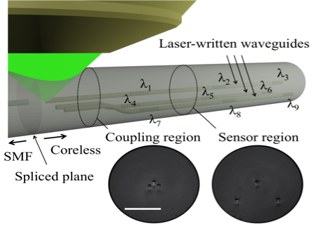
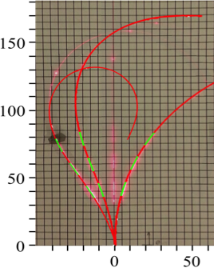
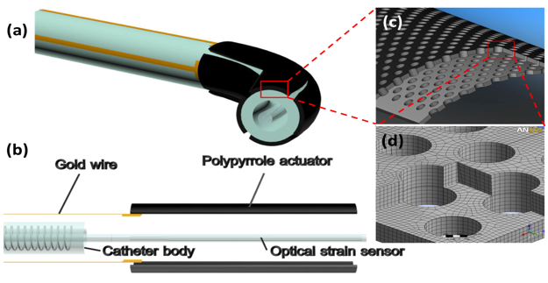
Fig. 1: Laser written distributed strain-temperature sensor (a) based on 3-arm BGWs (right inset) and 3-way directional coupler (bottom inset), with 3 examples (b) showing overlay of bent fiber (pink) and simulated fiber positions (red) showing 3D shape sensing. | Fig 2: Concept of smart catheter (a) and cross-sectional profile (b) showing laser writing optical strain gauge and laser-structured PPy actuator membrane (c).

(a)
(b)
Planar lightwave circuits and interconnects: Methods of spatio-optic beam shaping are applied, harnessing diffractive optics (spatial light modulator; SLM) to preferentially shape the laser focus and reach selectively inside to process pre-existing optical circuits. The objectives are to build new circuit links or devices, for example, vertical connects and polarization tuners or taps that are not possible to build in these circuits by conventional fabrication methods. Aberration correction is developed to permit deep writing in conventional circuit platforms of planar silica waveguides and enable polarization trimming, WDM spectral tuning, and linking of multi-layer waveguide stacks for dense 3D photonic circuitry. With improving precision, the laser processes will be scaled to reach inside cladding zones of silicon-photonic chips, where similar benefits are to be extracted. The project further exploits laser welding and FLICE to enable new 3D means of direct fiber-to-chip packaging, including edge, grating and adiabatic coupling. The hope is to help unlock the last remaining roadblock for silicon-photonics such that silicon photonics can finally take off as the next generation optical platform for telecommunications and signal processing. This project area involves several local and international industry partners.

Flexible Nanofluidic Lab-on-Chip: This project area exploits our new discovery for opening nano-scale holes in transparent glass, and seeking their integration into the 3D photonics and microfluidic microsystems as described in the above projects. The nano-hole size scale falls well below the dimension of cells and therefore opens a new means to selectively manipulate sub-cellular biological species within a robust all-glass lab-on-chip platform. The program is new and wide open to explore interrogation of protein, bacteria, viruses and DNA. The objective is to bring such nano-holes in controllable proximity of optical circuit elements for various forms of sensing, including phase contrast, fluorescence, multi-photon, evanescent, and plasmonic. Photonic bandgap concepts will be further explored while the dimensions of the circuit are thinned to flexible sizes (sub 100 μm). The student in this project will collaborate with other group members to integrate nano-holes into the optical fiber or silicon photonic chip. The collaboration further extends to outside research groups in engineering, biology, and medical sciences and will attract new industry partners.

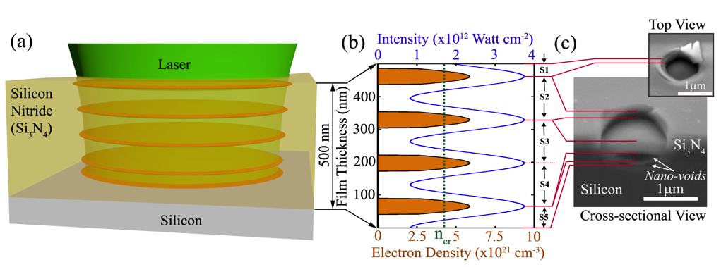
Quantized-Thin Film Ejection: Nano-structuring of materials is the basis of rapidly expanding application areas where ultrashort pulsed lasers are becoming a tool of choice with benefits of non-contact processing that precisely shape and pattern with very little residual damage. The student will join a highly promising study area around our recent discovery of a laser interferometric interaction for nanostructuring inside thin transparent film. Here, optical interference fringes are formed parallel with the film surface on femtosecond timescales. For the first time, lasers can create thin laser plasma disks and thereby form nanocavities, thin blisters, lateral cleavage planes and quantized ejection on small (~ 200 nm) half-wavelength periods. These thin plasma interaction zones open a new means of control not been previously anticipated, and is especially attractive in high temperature dielectric media like optical films that find widespread use in processing microelectronic, optical, lab-on-chip, photonic, MEMs, and photovoltaic devices. The research program aims on one level to improve our fundamental understanding of opposing nonlinear interactions where interference and self-channeling (filamentation) can play together in transparent films and plates and serve as a basis for developing new nano-optical devices and forming novel nanostructured glasses. We are seeking bio-inspired concepts to strengthen windows for low-weight sunroofs, invent new types of anti-reflection surfaces and compact microlens arrays, and provide three-dimensional volume texturing for improving adhesion, wetting, or biosensing. Alternatively, the ‘quantum’ laser interaction offers the opportunity for generating complex multi-layered nanofluidic networks inside thin film that may permit flexible lab-in-film devices to be integrated with smart phones, cameras or microelectronic chips. The project involves industry and academic partners.
Fig. 1: Depiction (a) depicting thin laser-interaction zones (orange discs) inside a SiNx film due to the laser interference of Fresnel reflections from boundary interfaces, (b) modulated laser intensity and electron density profile (shaded) calculated inside the film, and (c) scanning electron microscopy (SEM) images showing ejections, blistering and nanovoids in a 500-nm thick film after laser exposure.

Examples of Funded Projects:

Controlling femtosecond laser processing: smart fibers, catheters, and lab-on-fiber concepts (Industry Partners / NSERC Strategic Project)

Quantized Structuring of transparent film and plates with ultrafast laser interference and filamentation (Industry Partner / NSERC Strategic Project)

Femtosecond laser direct writing of out-of-plane wavegudies for PLC (US Industry Partner)

Femtosecond Laser: tailoring extreme laser interaction physics for nano-processing (NSERC RTI)

Femtosecond laser direct writing: High-Density 3D Optical I/O for MCF to Si-Photonic Chip (Asian Industry Partner)

3D Laser Nanofabrication: enabling nano-optics for the nano-sciences (NSERC Discovery)

Femtosecond laser direct writing of fibre Bragg grating sensors through the polymer
Coating (Canadian Industry Partner)

Laser generated nano-holes (Asian Industry Partner)

Femtosecond laser writing of out-of-plan waveguides for PLC Gyroscopes (US Industry Partner)

